Procedure for Deducting and/or Extending Leave in Excess of 280 Hours of Vacation Leave
Questions and Answers (Q&A)

What is the maximum number of hours of vacation leave that I can accumulate?
As per Washington State law and the applicable collective bargaining agreements for classified and exempt student support services staff union, vacation leave may be accumulated to a maximum of thirty-five (35) working days or two hundred eighty hours (280) hours on the employee’s anniversary date. For example, a full-time employee who works 8 hours per day and 5 days per week, the vacation leave maximum at their anniversary date would be 280 hours (8 hours x 35 days = 280).

What is an anniversary date?
A staff employee’s anniversary date is the most recent date of hire into state service (i.e., it does not include time as a student employee or time in a temporary, hourly position). An employee receives a new anniversary date when that employee is rehired following a break in state service, but not when the employee promotes, demotes, or transfers to another position.

Who is responsible for knowing what my anniversary date is?
It is the responsibility of each employee to know their own anniversary date.

If I don’t know it, how can I find out what my anniversary date is?
If you don’t know your anniversary date, you may obtain the information on the ‘Leave History’ tab in the Leave System. View the graph at the bottom of the screen, and your anniversary date is listed on the left side of the graph.
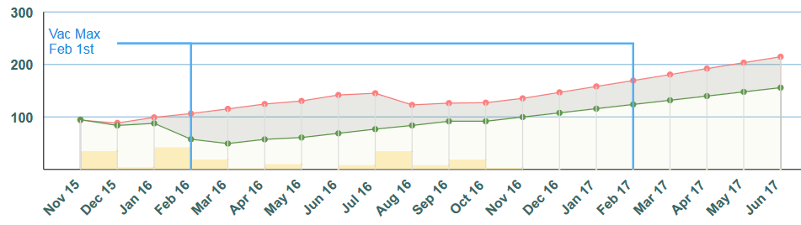
Note: Red line represents vacation leave balance projections. If the red line intercepts or is above the blue line the vacation leave balance will be at or above 280 hours on the anniversary date. See example below.
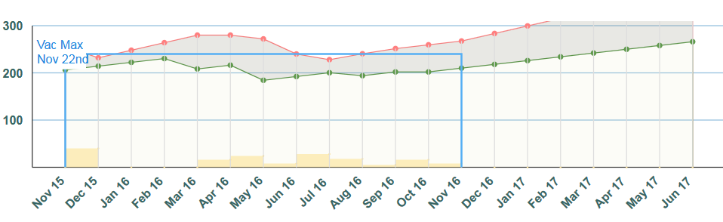

What happens if I don’t use the vacation leave hours that are in excess of two hundred eighty (280) hours by my anniversary date?
As per state law and the applicable collective bargaining agreement, if an employee does not use the excess vacation leave by their anniversary date, the excess leave is automatically extinguished or lost, deducted from the employee’s leave balance, and is considered to never have existed.

When may vacation leave be accumulated above the maximum two hundred eighty (280) hours?
An employee may accrue vacation leave in excess of two hundred eighty (280) hours prior to their anniversary date, but the excess hours will be lost unless an extension (i.e., deferral) has been granted.

What is the procedure for requesting an extension of hours in excess of two hundred eighty (280)?

After a vacation leave request has been submitted and denied in the Leave System and prior to the employee’s anniversary date, an employee and their supervisor may request an extension of hours in excess of two hundred eighty (280) by submitting a timely written extension request to Human Resource Services. The written extension request may be submitted by letter, memorandum, or e-mail at LeaveAdminDL@evergreen.edu - and must include the following information:

- The reason(s) why the vacation leave request was denied (e.g., employer convenience, operational/staffing issues);

- The date, prior to the employee’s next anniversary date, for which the excess vacation leave will be used.

If an employee is approaching over 280 hours vacation leave balance on their anniversary date, the Leave System will generate an email to employee and their supervisor with a courtesy notification about the 280 maximum balance procedures.

What are some examples of when an over two hundred eighty (280) hour extension request may be denied?
Human Resource Services may deny an over two hundred eighty (280) hour extension/deferral request, in whole or in part, for reasons such as, but not limited to, the following:

- The employee submitted the vacation leave request in the Leave System after their anniversary date. All leave requests related to an extension of excess vacation leave hours must be submitted by the employee in the Leave System prior to the employee’s anniversary date.

- The vacation leave request and denial were done by verbal agreement between the employee and supervisor. Only those vacation leave requests that are submitted and denied via the Leave System, with the required written request statement (see above procedure section for requesting an extension), will be considered.

- The employee is not close to the two hundred eighty (280) maximum and/or their anniversary date at the time the vacation leave request is submitted and denied.

- The written extension request is not timely (see procedure section above). Extension requests that are submitted weeks or months after the anniversary date are not considered timely.

- When there are not enough hours or days left before the employee’s anniversary date, as there are excess accrued vacation leave hours. For example, if an employee has ten days or 80 hours of excess vacation leave but the vacation leave request is entered into the Leave system three days prior to the employee’s anniversary date, the only possible extension that may be approved would be for the three days.

RCW 43.01.040; RCW 41.06.070
RCW 43.01.044

