Native Fishing Practices and Oxygen Depletion in Hood Canal

By

Robert S. Cole, the Evergreen State College

Abstract
This case examines the contribution of dumping chum salmon carcasses into Hood Canal to the lowering of dissolved oxygen in the Canal. A report by the Puget Sound Action Team and the Hood Canal Coordinating Council studied the contribution of different factors to low dissolved oxygen levels in Hood Canal. This report presented the Skokomish Tribal Nation with a potential public relations issue regarding their traditional practices of dumping the chum salmon carcasses into the Canal. Students are challenged to discuss recommendations about what actions the Skokomish Nation should take based upon the findings of the report, upon issues of economic impact on tribal fishers, and upon issues of equity in addressing environmental problems.

Part 1 Scientific Background
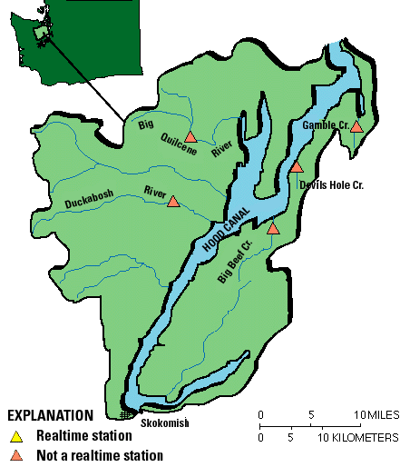
When a variety of fish and shellfish began washing ashore in the southern reaches of Hood Canal in the summer of 2003, Washington State Fish and Wildlife officials, scientists, commercial and recreational fishermen, natural resource managers and other citizens became quite concerned. For several years scientists had been aware of declining dissolved oxygen (DO) levels in the waters of Hood Canal (summarized in Newton, 2002 and Newton, 2003), but the summer and fall of 2003 raised alarm in several quarters. The Washington Department of Fish and Wildlife enacted fishing closures because of the dying marine life.
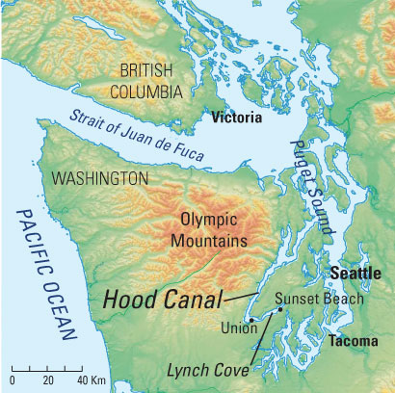

Figure 1 Location of Hood Canal
Both Maps courtesy of the United States Geological Survey, USGS
Measurements taken soon thereafter by the University of Washington research teams, found extremely low, to lethal, levels of DO in several portions of the southern end of Hood Canal (HCDOP 2004). Fish, shellfish and most forms of marine life cannot exist when DO levels are low. Lethal levels are, of course species dependent, but anything below two milligrams per milliliter (2 mg/L) is considered lethal to most species. Biological stress is observed in many species at 5 mg/L. Several studies ensued, and they documented the degree of DO depletion in Hood Canal (HCDOP, 2004). Not only were large sections of the southern end of the Canal found to be severely depleted in DO, many portions of the northern Canal showed significant lowering of DO to biological stress levels for as much as six months out of the year.

Hood Canal, carved by glaciers in the most recent ice age, is an arm of Puget Sound, an Estuary of National Significance. It is an L-shaped fjord with water depths of up to 500 feet. It is roughly sixty miles in length, while its width varies from approximately one-half mile to four miles. While much of the Canal is fairly deep water for the width of the channel, there is a shallow area, or sill, that transects the Canal east to west at the northern end of the Canal, just south of the Hood Canal Bridge. This sill tends to limit water exchange going into and out of the Canal. Five major rivers flow eastward out of the Olympic Mountains into Hood Canal. They are high gradient rivers that have cut through the hard Crescent Basalt that forms the eastern rim of the Olympic Peninsula. Because they are high gradient they tend to carry high levels of dissolved oxygen (typically above 11 mg/L). This oxygen-rich fresh water tends to float on the surface of the canal, although it does mix with salt water slowly. Prevailing winds tend to push the freshwater northward to the

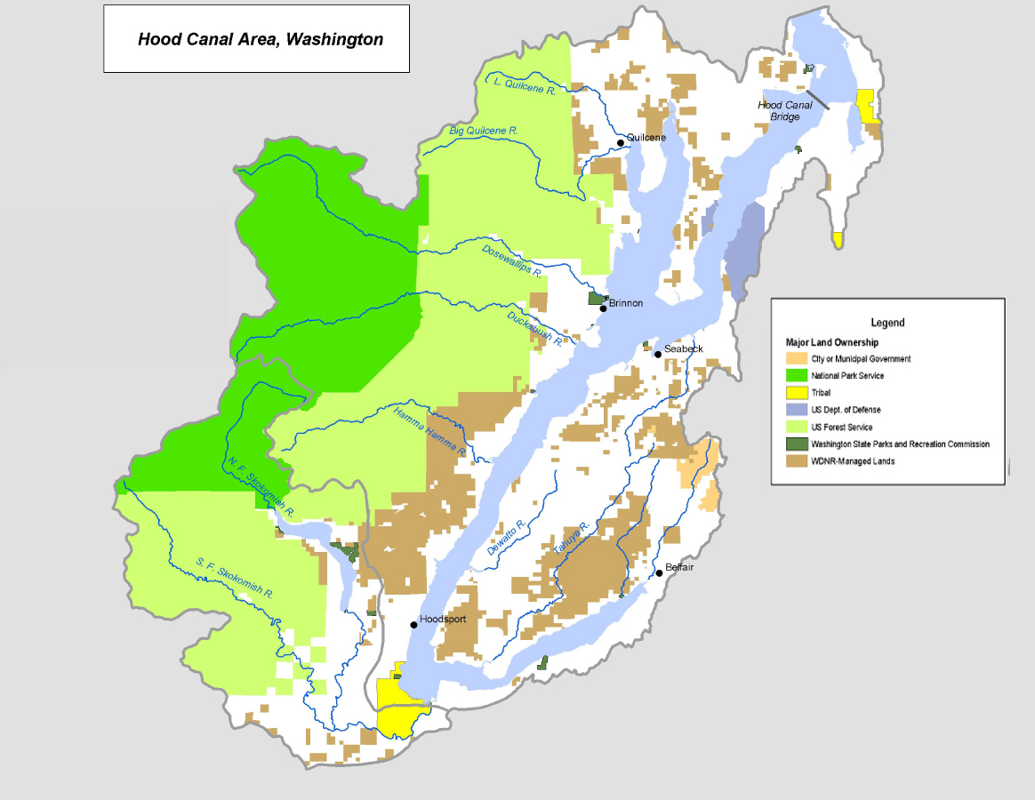
Figure 2 Major Land Ownership Along Hood Canal (from the PACA Report)
Map courtesy of the Puget Sound Action Team (PSAT & HCCC, 2004)
Straights of Juan de Fuca. All of these factors tend to make Hood Canal a place where the fresh water and salt water don’t mix as thoroughly as they do in other parts of Puget Sound. The waters do mix, but they do so in a relatively slow fashion. This makes Hood Canal susceptible to having lower oxygen levels by introducing just a small amount of pollutants like nitrates and nitrites.

Hood Canal has roughly180 miles of shoreline, with about 54,000 people living within the watershed. The last fifteen miles of the Canal bend eastward at Annas Bay. The mouth of the Skokomish River, and the location of the Skokomish Reservation, is at the southwest corner of this bend.

Several activities of humans were thought to be the primary contributors to DO depletion, including fishing activities, waste water management from a myriad of septic systems of homeowners along the canal, agricultural runoff, storm water runoff from adjacent towns and cities along the Canal, forestry practices in the Hood Canal watershed, and hydropower diversions of stream water at the southern end of the Canal. In each case, the primary contributor to lowered DO was thought to be inorganic nitrogen compounds like nitrates (NO₃), and nitrites (NO₂). These nitrogen compounds readily combine with the dissolved oxygen in water, thereby lowering the DO available to other organisms.

In early 2004 the Puget Sound Action Team (PSAT), the Hood Canal Coordinating Council (HCCC), in collaboration with the University of Washington (UW) published a report, Hood Canal Low Dissolved Oxygen: Preliminary Assessment and Corrective Action Plan (PSAT & HCCC, 2004), listing several potential sources of nitrogen, thought to be the primary cause of the low dissolved oxygen in Hood Canal. The Skokomish Nation was part of the Hood Canal Coordinating Council, and the Skokomish worked very closely with the team in producing the report. The results of the study are summarized in Table 1 and the graph in Figure 3, below, which show the range of nitrogen compounds (in tons) estimated to be contributed by each of six sources.

Nitrogen Source | Annual Range of Nitrogen Compounds (tons)
Human sewage (onsite systems) | 39 - 241
Stormwater runoff | 12 - 24
Chum salmon carcasses | 16 - 24
Agriculture (animal) waste | 18 - 22
Forestry | 0.5 - 5
Discharges from point sources | 0.3 - 3
Table 1

Data from PSAT & HCCC, 2004

Figure 3
Data taken from PSAT & HCCC, 2004 and graphed on a spreadsheet

Each of these ranges represented an estimate of actual inputs because none of the inputs were being directly measured. However, these estimates were based on rigorous scientific methods, and represented the best scientific understanding at that time. The authors of the report state that they believe the exact figures for each category is likely to be in the middle of the range for each category (PSAT & HCCC, 2004). The largest source of nitrogen input, by far, is from leaking onsite sewage systems. This leakage is considered non-point source pollution, because it does not come from a specific location (like a pipe into the water). Rather, non-point pollution results from overland seepage (like stormwater), or from seepage into the ground water which often reaches Hood Canal some distance away from where the pollution enters the ground water. Point source pollution comes from a readily identifiable location (like the end of a pipe). All of the above categories, except the last one (discharges from point sources) represent non-point source pollution. The source of nitrogen of interest to this case study was the disposal of chum salmon (Oncorhynchus keta) carcasses by the Skokomish Tribe, specifically the practice of discarding the chum salmon carcasses after the roe of the female was extracted. While the estimated range of nitrogen compounds from these practices was quite low (Table 1 and Figure 1), the fact that the PACA report listed this source explicitly presented a potential public relations dilemma for the Skokomish Nation.

The fall chum salmon run is a hatchery-supplemented run. Therefore this fall run tends to be a large run, but of a lesser quality fish for commercial purposes. Chum salmon are not prized as an eating fish, unless they are particularly bright in color when caught. The market for fall chum is primarily roe (egg sacs) as a wholesale item. There is a market difference between loose eggs and tight ‘skeins’ or egg packs, and this helps determine when and how the fish are landed. The bulk of these fall run chum are hatchery-bred at the Washington State Fish and Wildlife Hatchery on Finch Creek near Hoodsport. Although not prized commercially, chum salmon are relatively inexpensive to raise in a hatchery because they can be released to salt water a few weeks after hatching. Chinook and coho salmon require holding pens and a longer rearing stage prior to release to salt water. The fall run chums were not a natural run that the tribe historically caught, but is one that the Skokomish have been fishing for the last fourteen to eighteen years (Keith Dublanica, private communication).

The PACA report examined each of the categories in terms of seasonal effects. For instance, stormwater runoff occurs primarily in the winter months, but leakage from onsite sewage systems occurs year-round, and may even peak in the summer months because of the higher population of summer residents and vacationers in the Hood Canal watershed. Figure 4 shows the seasonal projections for nitrogen sources analyzed by the PACA report.
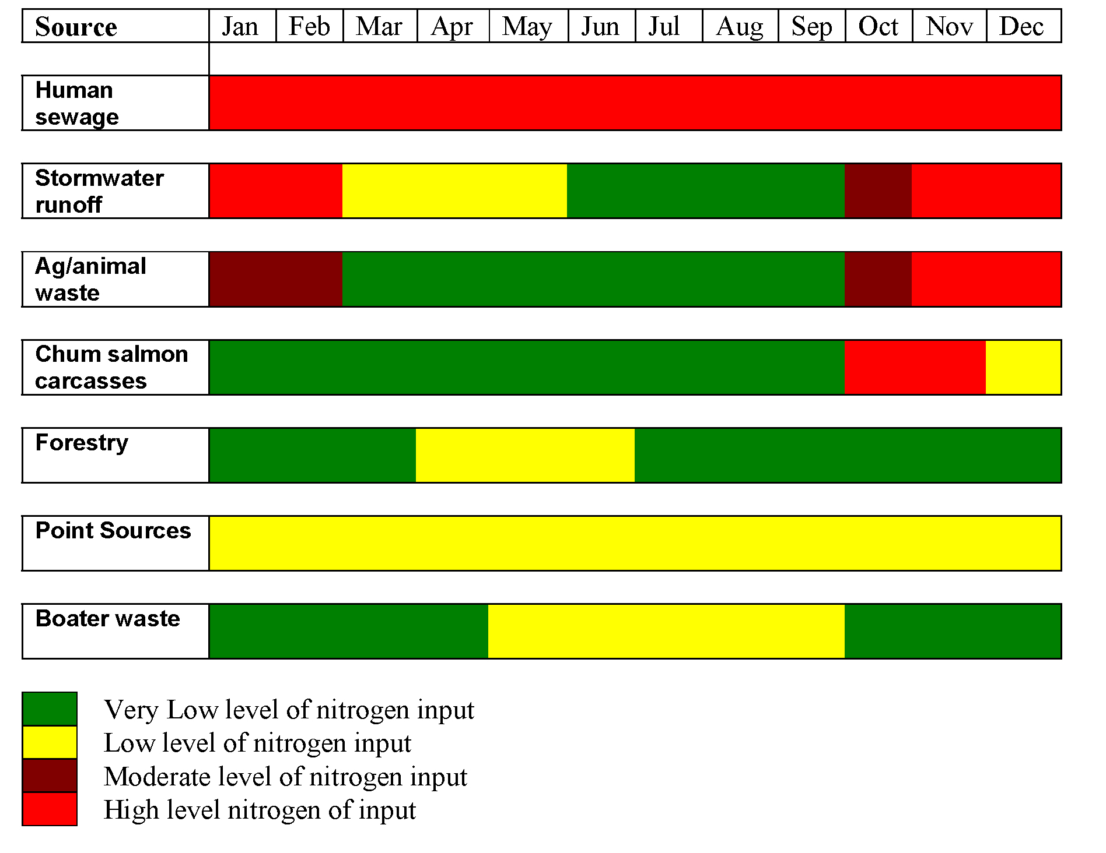

Figure 4 Seasonal Nitrogen Inputs to Hood Canal (from the PACA Report)
Figure courtesy of the Puget Sound Action Team (PSAT & HCCC, 2004)
Discussion 1
Discuss with members of your group what factors contribute to Hood Canal’s being inherently susceptible to low oxygen conditions. Why might high gradient rivers along the east side of the Olympic Peninsula have high dissolved oxygen content? Why would fresh water tend to float on top of salt water? Which of the categories in Figure 4 might be of most concern for causing low levels of dissolved oxygen during the months of late spring, summer and early fall?

{discussion}
The Skokomish Nation is at the southern end of Hood Canal, at the mouth of the Skokomish River. In 1855, the Treaty of Point No Point (Treaty of Point No Point, 1855) established the Skokomish Reservation at the mouth of the Skokomish River at the southern end of Hood Canal. Article 4 of this treaty states:
The right of taking fish at usual and accustomed grounds and stations is further secured to said Indians, in common with all citizens of the United States; and of erecting temporary houses for the purpose of curing; together with the privilege of hunting and gathering roots and berries on open and unclaimed lands….

The website of the Skokomish Nation (http://www.skokomish.org/ ), states the following regarding their cultural history:
What is now known as the Skokomish Tribe actually was primarily composed of Twana Indians, a Salishan people whose aboriginal territory encompassed the Hood Canal drainage basin in western Washington State. The tribe's first recorded direct contact with European culture came in 1792 and resulted in a devastating smallpox epidemic that took the lives of many. There were nine Twana communities, the largest being known as the Skokomish, or "big river people." The Twana subsisted on hunting, fishing and gathering activities, practicing a nomadic life-style during warmer weather and resettling at permanent sites during the winter. Twana descendants live on the Skokomish Reservation, and all have become known as the Skokomish Tribe….

Today, many tribal members continue to work within the region's fishing and logging industries. In an attempt to diversify its economy, the Tribe has purchased property for economic development and resource enhancement, as well as for housing. The Tribe operates its own businesses including a tribal hatchery and a gas station/convenience store. As for traditional culture, a number of ceremonies that had been dormant for 70 years or more were re-established during the late 1970's and early 1980's. Traditional basketry, carving and dance projects represent other facets of the reemerging interest in traditional arts of the Skokomish Reservation.

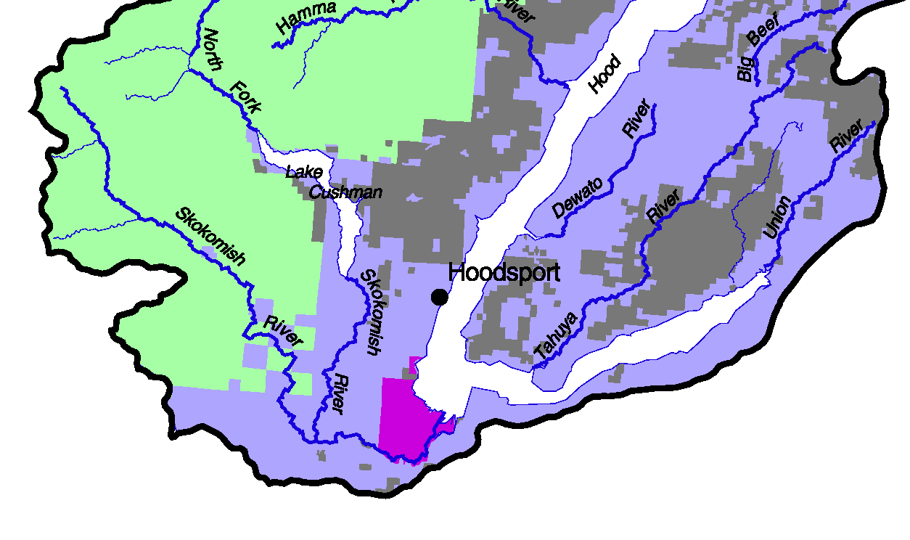
Because the Skokomish Reservation is at the mouth of the Skokomish River, the Skokomish feel the multiple effects of the dominant culture’s logging, agriculture, hydroelectric generation and development upstream. Each of these activities has had major impact on salmon spawning in the Skokomish River, including the alteration of the hydrology of the River, resulting in frequent flooding of the Skokomish River Valley and Reservation lands. This has resulted in an intricate web of environmental and economic issues in which the Skokomish Nation is actively involved. This particular case is just one of those issues.
Figure 5 Southern Hood Canal,
Skokomish Reservation in magenta
Map courtesy of NOAA, National marine Fisheries Service,
Habitat Conservation Division, Northwest Regional Office
http://www.nwr.noaa.gov/ESA-Salmon-Listings/Salmon-Populations/Maps/upload/chumhc.pdf Accessed 3/23/07

Chum salmon return from several years at sea to the rivers in the Pacific Northwest each fall, and run upstream to spawn very close (often within a few hundred feet) of where they themselves were born. The fall run of chum lasts between six and eight weeks on the Skokomish River. Chum salmon are considered to be of slightly inferior quality to other species, so there has been no American market for chum salmon meat or carcass. As a consequence, for years the tribal fishers had extracted the roe which is sold competitively on the international market as caviar. The carcasses were discarded in the water, usually by taking them offshore in a boat and dumping them in deeper water. The tribal fishers did not think this method was substantively different from the natural life-cycle of salmon carcasses rotting along the stream banks after spawning, with all the nutrients (including nitrogen compounds) washing downstream to Hood Canal. The thought had been that these carcasses served as a food and nutrient source for a variety of bottom dwellers, including shrimp and crab.

However, the PACA report suggested that the Skokomish practice of dumping carcasses might account for 16 to 24 tons of nitrogen, annually, dumped into Hood Canal. This number was substantially lower than nitrogen from human sewage from leaking septic systems, but large enough to attract the attention of the general public. In addition the Skokomish practice was something specific to focus upon – dealing with septic systems on thousands of private landholdings represented a massive and costly project. It appeared to some that eliminating salmon carcasses from the Canal was more straightforward, in terms of costs and actions, than dealing with potentially several methods of addressing septic system leakage from thousands of home sites.

The local newspaper had not been generally sympathetic with the tribal fisheries actions since the time of the Boldt Decision (United States v. State of Washington) in 1974. Phase 1 of this Federal Court Decision guaranteed half of the present annual fishing harvest to tribal nations, based directly on Article 4 of the Treaty of Point No Point, 1855. Phase 2 of this Decision mandated a healthy habitat to guarantee healthy fish runs. The Boldt Decision made the general public more aware of tribal sovereignty, and reinforced the treaty rights of the Tribal Nations. The fact that many in the dominant culture were not happy with the Boldt Decision has simply made it more important for Tribal Nations to continue their efforts to preserve and expand their sovereignty, and these efforts persist to the present. So, the Skokomish felt faced with potential public relations and economic dilemmas. While they retained their treaty rights to fish in the usual and accustomed places, they could continue their practices of dumping salmon, and risk expressions of anger from the general public, or they could, at some real expense to their fisheries operation, attempt to dispose of the carcasses in some other fashion.

The PACA report suggested corrective action for each of the six areas that contributed to nitrogen input into Hood Canal. All of the corrective actions were based on sound science, but many of the recommendations for corrective actions lacked potential for an immediate impact. For example, the actions recommended for correcting the human sewage input from onsite systems were: (1) assessment and sewage treatment facility construction, (2) use of state-of-the-art technology to insure that treated sewage had low-nitrogen concentration, and (3) the development of education programs and the development of marketing incentive programs to get homeowners to act. Specific timetables and specific costs were not discussed in the PACA report.

The science of sewage treatment has focused upon the removal of pathogens from the treated sewage to protect the public health. The removal of nitrogen compounds has not been a scientific objective, or a regulatory target for the public health departments that oversee sewage treatment. While the bacterial process in all sewage treatment plants does convert some of the nitrogen compounds to nitrogen gas, N₂, which is vented to the atmosphere, many nitrates and nitrites remain dissolved in treated sewage effluent. Traditional sewage treatment processes do remove some nitrogen from sewage, so a treatment plant would be better than runoff from onsite septic systems. But to remove more nitrogen compounds the PACA report urged the usage of state-of-the-art technology focusing specifically on the removal of dissolved nitrogen compounds. They urged this new technology for treatment of aqueous effluent of the proposed sewage treatment plants, as well as from completely new onsite septic systems. Such an undertaking would be both expensive and time consuming. However, subsequent to the publication of the PACA report the Skokomish Indian Nation, Mason County and Public Utility District #1 signed a Memorandum of Agreement to address wastewater issues along Hood Canal between the Reservation and the town of Hoodsport.

For stormwater runoff (whose estimated contribution was comparable in magnitude to the chum salmon carcass dumping), the corrective actions recommended were: (1) programmatic improvements to manage stormwater more effectively, (2) educational and incentive programs targeted at residents to reduce the input of nitrogen from landscaping practices and pet waste, and (3) implementation of low impact development practices. These actions really consist of urging counties and other administrative units to adopt best management practices (BMP’s). Presently some BMP’s for stormwater include construction of grassy swales to slow runoff, infiltration basins, detention/retention ponds, constructed wetlands and engineered structures such as vaults and oil/water separators. These BMP’s will reduce peak flows of stormwater to streams during and immediately after rain events, and help reduce chemical pollutants and silt that reach streams. However, none of these practices is specifically designed to remove nitrogen compounds from stormwater, so the recommended corrective actions of the PACA report, in this case, don’t go very far to address the reduction of nitrogen compounds reaching Hood Canal. The PACA recommended corrective actions (2) and (3) above do address the reduction of nitrogen reaching Hood Canal, by focusing on reducing nitrogen runoff from fertilizers on lawns and gardens and from pet waste.

For animal waste from agricultural activities, the PACA report recommended (1) providing manure and nitrogen management information, training and incentives, (2) promoting incentives for farmers to restore streamside and shoreline buffers to prevent agricultural runoff, and (3) providing incentives for farmers to protect and restore wetlands. Although agricultural runoff varies widely from site to site, researchers have estimated that roughly twenty percent of nitrogen applied to agricultural fields leaches into surface water or groundwater. While agricultural land use comprises roughly 3000 acres along Hood Canal, the PACA scientists estimated that the nitrogen input from these acres was in the range of eighteen to twenty tons per year. Their recommended actions focused primarily on horse owners. The Puget Sound Action Team’s excellent resource is Healthy Horses Clean Water (Puget Sound Action Team, 2001).

For the disposal of chum salmon carcasses in Hood Canal, the PACA report recommended (1) a search for buyers of the chum salmon meat for human or animal consumption, (2) development of strategies to quickly offload salmon carcasses during the fishing season so that fishers could spend more time fishing, (3) purchase of lease of on-land storage freezer or refrigeration facilities, or direct bulk sale of large quantities of fish (depending on their ultimate use, and (4) development of a land-based composting facility to handle the salmon carcasses. The lease expensive of these corrective actions, and the one that could be implemented most quickly, was the composting idea.

For forestry practices and for discharges from point sources the PACA report recommended corrective actions, but because magnitude of nitrogen input was so relatively small in both cases, we will not consider them further in this case study.

Discussion 2

Discuss with the members of your group the various corrective actions proposed by the PACA report. Who were the primary players in each of the categories of nitrogen contributions? Try to determine which corrective actions would actually remove nitrogen compounds from getting into Hood Canal. Which corrective actions might be considered fairly immediate in terms of reducing nitrogen input? Which actions might be considered to reduce nitrogen input over a longer time frame, specifically, what actions might lead to a long-term solution of eliminating nitrogen input to Hood Canal? Try to develop a consensus of which corrective actions you see as most important to implement immediately. Which actions might lead to the greatest reduction of nitrogen input in the least amount of time? Which actions might be the least expensive to implement? Some people have suggested that conservation activities are often done on the back of Native Peoples. Do you think that statement is at work in this case?

{discussion}

Part 2 The Dilemma for the Skokomish Nation

We’ve seen that many of the recommended corrective actions were longer term (for example, increase monitoring, create educational programs and incentive programs), or involved significant funding (for example, the proposal to create multiple sewage treatment facilities along the Canal to take the sewage from existing septic systems). One corrective action that appeared possible to do in a short time span was the stopping of disposal of salmon carcasses into Hood Canal. For this reason the Puget Sound Action Team and the Hood Canal Coordinating Council were urging the Skokomish Nation to take action in this area. These groups, working the Skokomish, were willing to seek initial funding to develop a pilot project to test the feasibility of removing the carcasses to one or more composting sites.

Many tribal fishers expressed concern that their disposal practices were being singled out, while the practices of other commercial fishers were ignored, and that sports-fishers in rivers all along Hood Canal would continue to dispose of fish innards along the river banks as they cleaned their fish. Many tribal fishers didn’t believe that the dumping of carcasses was that big of a problem, since fish carcasses had lined the riverbanks, with the nutrients of their decay flowing into Hood Canal, for tens of thousands of years prior to the Euro-American influx. The PACA report didn’t address this issue.

Moreover, some tribal fishers argued, the relative contribution to the decline in DO from the chum carcass disposal was quite small compared to leaky septic systems along the canal. The Skokomish salmon carcass contribution was comparable with nitrogen contributed by agricultural interests, and stormwater runoff from towns and cities along Hood Canal, but these later entities were doing little to reduce their own impact. In addition, the chum carcass dumping occurred primarily in the months of October and November, after the season of the severely low levels of DO in the Canal during the summer and later summer. Why should the Skokomish fishing practices be singled out, several tribal fishers asked. However, the Puget Sound Action Team and the Hood Canal Coordinating Committee involved in restoration efforts in Puget Sound were urging the Skokomish to develop a plan that would not involve the dumping of chum salmon carcasses. Some members of the Skokomish Natural Resources staff worried that if the Skokomish did nothing about the salmon carcasses, it would only provoke anti-Indian sentiment among the dominant culture citizenry along Hood Canal.

In the late spring of 2004 the Skokomish Tribal Council had to decide what to do about the chum carcasses during the fall 2004 chum salmon run. On the one hand, the Skokomish Fisheries and Natural Resources Departments were urging that carcasses not be allowed to be dumped in the Canal during the fall 2004 chum salmon season. They based their arguments on the recommendations of the PACA report, and on the notion that continuing to dump chum salmon would create a bad public relations issue for the Skokomish Nation. They also urged that the PACA recommendations be adopted because The Puget Sound Action Team had agreed to help secure funding for incentives for the Skokomish fishers, including fuel support, boat and truck time support, and assistance in finding a market for the compost derived from the chum salmon carcasses. On the other hand, a number, but certainly not all, of the Skokomish fishers argued that the nitrogen contribution from dumping salmon carcasses was small compared to sewage leakage from septic systems along the Canal. They felt they were being unfairly singled out, while the much larger problem of human sewage was not being addressed as quickly. They also argued that the very process of removing salmon carcasses to another location would cut into the short time the fishers had to catch fish, and thus reduce their income, which was already at a subsistence level.

Discussion 3

In your group, discuss the relevant issues raised by the Skokomish Fisheries and Natural Resources Departments and by a number of the tribal fishers. Try to reach a consensus within your group as to what you would advise the Tribal Council to do. The Tribal Council is an elected seven-member group of enrolled Tribal Members. The Council Member have staggered terms (with elections every June), and select their officers who conduct meetings under Roberts Rules of Order. List your reasons for your advice to the Council clearly and persuasively.

{discussion}

Part 3 The Implementation

In fact, the Tribal Council agreed to collaborate with the Puget Sound Action Team (PSAT) and in May of 2004 adopted a policy that would not dump salmon carcasses into Hood Canal, and would instead propose a composting strategy like the one suggested in the PACA. The Tribal Council adopted the Skokomish Treaty Fishing Ordinance 7.02.120 (k) which committed the Skokomish not to dump chum salmon carcasses into Hood Canal, and set up a series of fines for those Skokomish fishers that violated the policy. The Tribal Council, with the collaboration of the Tribal Fisheries and Natural Resources Departments, subsequently secured federal funding, through the office of Congressman Norm Dicks, to develop a plan and get funding to haul chum salmon carcasses to two sites, one adjacent to the Reservation and near to the shore of Hood Canal, and the other on Tribal lands, but further from the shore. The fish would be composted at these sites, using methods that would be developed as they proceeded. The federal funding came to the PSAT who in turn provided $210,000 to the Skokomish to develop this pilot composting project.

However, not all of the Tribal fishers were pleased with this arrangement. Many of them continued to argue that they would have to spend more time hauling fish carcasses to the compost sites, time that would be taken away from their fishing with their beach seines. This is important because the run of chum salmon lasts only a few weeks in the fall. The fishers argued that this would lower their income. Skokomish data already showed that 48% of the Skokomish families involved in fishing were at, or below, federal poverty levels. Any disposal process for the chum carcasses promised to be heavily labor and time intensive. Moreover, they were skeptical of the proposed plans to haul the carcasses away. The equipment necessary to haul the carcasses across the estuary lands from the shore where the fish were hauled in over to the composting sites was expensive, and it wasn’t clear initially that it would work in the fashion intended. Special vehicles would have to be obtained to deal with, potentially, three- to four-hundred thousand fish carcasses. In order to get good compost, carbon, in the form of wood chips, needed to be added, and the Tribe would have to purchase multiple trailer loads of a mixture of noble fir and red alder chips (adding to the cost for the fishers). There was no obvious market for the completed compost. Some of the fishers felt that this entire project would drive them out of business, while their non-Native American commercial counterparts were doing nothing visible to help reduce DO in Hood Canal. In short, they were skeptical and unhappy with the thought of not being able to dump their salmon carcasses.

Discussion 4

The staff of the Tribal Natural Resources Department was asked to work with the Tribal fishers, and to help persuade the fishers that this pilot project was worthy of their support. Put yourself in the position of the staff of the Tribal Natural Resources Department, and try to determine how you would respond to a group of these unhappy fishers. How would you design a program to persuade them to comply with, and cooperate with The Tribal Council in starting to use the PACA? Be as specific as possible, because you will be meeting with The Tribal Council and with a delegation of unhappy fishers in the near future.

{discussion}

References

Hood Canal Dissolved Oxygen Program (HCDOP), 2004. http://www.hoodcanal.washington.edu/index.jsp Retrieved March 23, 2007

Newton, JA, Albertson, SL, Van Voorhis, K, Maloy, C, and Siegel, E. 2002. Washington State Marine Water Quality, 1998 through 2002, Washington State Department of Ecology, Environmental Assessment Program, Publication #02-03-056, Olympia, WA

Newton, JA 2003. Low Dissolved Oxygen in Hood Canal: A Science Primer http://www.hoodcanal.washington.edu/aboutHC/scienceprimer.jsp Retrieved March 23, 2007

Puget Sound Action Team, 2001. Healthy horses, clean water: Horses for clean water: A guide to environmentally friendly horsekeeping. Report authors: Blickle, AR, Paige, J, and Clark, E. http://www.psat.wa.gov/Publications/HORSE_MAN.pdf Retrieved March 23, 2007.

Puget Sound Action Team and Hood Canal Coordinating Council (PSAT & HCCC), 2004. Hood Canal Low Dissolved Oxygen: Preliminary Assessment and Corrective Action Plan. Report authors: Fagergren, D, Criss, A, and Christensen, D. (Publication # PSAT04-06). Puget Sound Action Team and Hood Canal Coordinating Council. http://www.psat.wa.gov/Publications/hood_canal/HC_PACA.pdf Retrieved March 23, 2007

Treaty of Point No Point, 1855. Point No Point Treaty Council. http://www.pnptc.org/treaty_of_point_no_point.htm Retrieved March 23, 2007

Washington State Department of Natural Resources and Washington Department of Fish and Wildlife, 2001 Final Supplemental Environmental Impact Statement, “State of Washington Commercial Geoduck Fishery”. (DNR, 2001)

Copyright held by The Evergreen State College. Please use appropriate attribution when using and quoting this case. Special thanks to Keith Dublanica and Lalena Amiotte of the Skokomish Tribal Nation Department of Natural Resources for their help in writing this case.
U.S. v. Washington, 1974 provides the legal framework for the co-management of hatcheries in western Washington by the tribes and the state. Since 1985 the Puget Sound Salmon Management Plan (PSSMP) has guided hatchery operations by the co-managers. Co-managers have coordinated the implementation of the PSSMP with the recommendations of the Hatchery Scientific Review Group, and with recovery planning under the Endangered Species Act. (Puget Sound Salmon recovery Plan, Draft, 2005 pp. 114-115)

