Dam Removal on the Elwha River: Salmon Recovery, the Restoration of Klallam Livelihoods and the Role of Cost-Benefit Analysis
Peter Dorman

Abstract: The Lower Elwha Klallam Tribe, whose ancestral home is on the northern coast of the Olympic Peninsula, has made a remarkable recovery from dissolution and poverty, reclaiming tribal status and acquiring land and fishing rights. Critical to this process will be the restoration of salmon runs on the Elwha River, which had been terminated by the building of two dams early in the twentieth century. Among the steps leading to dam removal was a cost-benefit analysis (CBA). This study, which was filed in 1995, forms the centerpiece of this case. Due in part to the CBA’s conclusion that the economic benefits of dam removal would exceed the economic costs, resistance to this precedent-setting decision was overcome. The case centers on an examination of the CBA and the ways it both does and does not incorporate matters of concern to the Lower Elwha Klallam Tribe.

I. Context

For thousands of years, the Lower Elwha Klallam have lived along the north coast of what is now the Olympic peninsula in Washington State. Their name means “strong people”, and they drew their livelihood primarily from the fish and shellfish abundant in this region, but they also settled and traveled up the Elwha river valley, harvesting medicinal plants and hunting wildlife. They prospered until the coming of white settlers, when they lost their land, their freedom and their way of life. (Valadez, 2002 and Boyd, 2009)

The Lower Elwha Klallam who lived at the mouth of the Elwha River were signatories of the Treaty of Point No Point (1855), along with other Klallam groups (Port Gamble and Jamestown S’Klallam). which required them to move to the Skokomish reservation on Hood Canal, but they refused to relocate. Instead, they sought to remain in their home region in any way they could: squatting, buying land, hiring out to timber and other companies. Over time, however, their situation became increasingly precarious. Their legal status outside the reservation was undermined by the treaty, and their settlements were seized whenever whites took an interest in their land. Even when they were fully paid-up property owners, Lower Elwha Klallam were at risk of having their homes burned down and being forced to flee. Washington State passed a series of laws that undermined their fishing rights, and those who resisted were routinely imprisoned. The lowest point came in 1912, when a poorly constructed dam on the Elwha river failed, destroying a community that had been established at the river’s mouth.

By 1930 the Lower Elwha Klallam seemed to have reached the end. They were scattered into isolated families, forced to turn to occupations that had little to do with their traditional livelihood. They had no tribal institutions and were in the process of losing their language and collective memory. It was at this nadir that they found the opportunity to resurrect themselves.

The first step came thousands of miles away, in Washington DC, with the passage of the Indian Reorganization Act in 1934. Although the law had both benefits and costs for tribes and has remained controversial, it was a godsend for the Lower Elwha Klallam. Under its provisions, the Klallam had the legal basis to reconstitute themselves as a group of tribes, and the government had a budget to help them acquire the necessary land. Initially the federal government wanted the Klallam to organize themselves into a single tribal entity, but instead three tribes were created, reflecting their longstanding history as distinct communities. Of particular interest for this case is the Lower Elwha Klallam, grouped near the mouth of the Elwha River. Initial land acquisition toward the creation of a Lower Elwha Klallam Tribe began in 1937, and in the following years their land holdings were gradually enlarged. Finally, in 1968, they achieved tribal status on a reservation that today encompasses nearly 1000 acres.

The next step was the recovery of fishing rights. The first step in this process occurred in 1974, when the US district court ruled that state laws restricting native fishing were in violation of federal treaty obligations, U.S. v. Washington, 1974—the “Boldt” ruling, named for Judge George Boldt. Washington State refused to enforce this decision, however, and for several years there was a confused situation in which Judge Boldt and the state issued conflicting orders. Final resolution arrived only in 1979, when the U.S. Supreme Court upheld U.S. v. Washington and compelled the state to back down. (Dudas, 2005) This legal turnabout ended decades of harassment of Klallam fishers and opened the door to a revival of traditional livelihoods. There was one missing element, however: the fish. Although a legal mandate for restoration of salmon habitats lay well in the future (Brown and Footen, 2010), it would turn out that another road lay open to the Klallam for recovery of salmon runs.

Before the twentieth century, the Elwha watershed provided one of the most productive salmon habitats on the Olympic peninsula, supporting runs of all ten anadromous species. One tribal elder, interviewed in 1976, recalled, ““When I went out fishing with my grandmother, I would catch 50 fish. She would catch 100. We’d carry them back in a wheel-barrow.” (Winter and Crain, 2008) It is not surprising that the Elwha would have been such a boon for salmon. The river, which is 45 miles long, drains a watershed of 321 square miles, most of it in what is now Olympic National Park. Numerous tributaries are sustained by the immense snow accumulation in the higher elevations; these and the stem river are cloaked in temperate rain forest and provide ideal habitat for spawning adults and developing juveniles. (Ward et al., 2008) The location and dimensions of the Elwha watershed can be seen in Figure 1.

Virtually all of this habitat was shut off when the Elwha dam was completed (following its disastrous blowout) in 1913. Rising over 100 feet and situated five miles up the river, the dam made no allowance for fish passage, despite state laws at the time that required it. Instead, the dam’s builders installed a hatchery below the dam, but the hatchery was unproductive and was closed soon after it opened. Within just a few years, salmon and trout were all but gone. Then a second dam, Glines Canyon, was completed in 1927 further up the river. Fish, game and riparian habitat were all damaged.

Figure 1: The Elwha Watershed
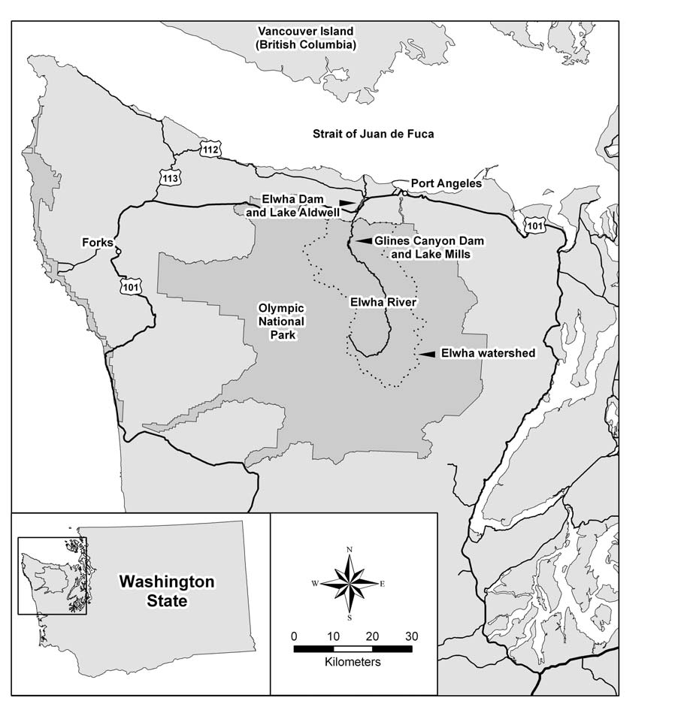
Source: Ward et al. (2008)

This situation persisted until 1976, when the Lower Elwha Klallam Tribe (hereafter Tribe) insisted that relicensing hearings be held to determine the soundness of the Elwha dam, since it was suspected that the repairs made in 1912-13 were not as thorough as they should have been. The Federal Energy Regulatory Commission (FERC) assumed jurisdiction and brought the two dams together under a single relicensing procedure. This opened the door to further litigation, however, since the Glines Canyon dam was within the boundary of the Olympic National Park, which had been created in 1938, a decade after the dam, and therefore the National Park Service could also make a claim. (Gowana et al., 2006)

As the bureaucratic wheels turned, the Tribe added a new element in 1986, when it called for the removal of both dams in order to restore anadromous fish runs. Soon after, several environmental groups endorsed dam removal as well, while various state and federal agencies began to consider less sweeping approaches to returning salmon to the Elwha. Later that year, the Tribe joined with the Point-No-Point Treaty Council (representing two other Klallam tribes), the US Department of the Interior, the National Marine Fisheries Service and the Washington State Department of Game to create the Joint Fisheries and Wildlife Agency (JFWA), and a few months later they petitioned FERC to commission studies to determine how salmon restoration could be achieved. FERC agreed and asked the current owner of the dams, the James River Company, to prepare reports. James River accepted, hoping to put the uncertainties surrounding relicensing behind them. (Gowana et al., 2006)

To their surprise, James River found that modest measures, such as installing fish ladders, would do little to restore runs: only one species, steelhead, was expected to respond, and only a low population could be supported. As a result, the options polarized; either FERC would have to give serious consideration to dam removal, or the goal of restoring anadromous habitat would have to be abandoned. At this critical juncture, the Tribe financed a study to support the feasibility of dam removal, countering the arguments by dam proponents that this would be a complex and costly engineering problem. By now it had brought the rest of its allies in the JFWA on board, and the movement to take down the dams had become a groundswell.

Congress responded in 1992 by passing the Elwha River Ecosystem and Fisheries Restoration Act. This law virtually mandated dam removal by setting ecological goals that dam modification could not meet, and by mandating that a “definite plan” for removing the dams be drawn up. It would not be an exaggeration to say that this was a history-making commitment: for the first time ever, in the United States or in any other country, a decision had been made to dismantle functioning dams for the sake of restoring the environment they had destroyed. Nevertheless, there were still hurdles to be surmounted. In particular, Congress stipulated that a series of environmental and other reports be submitted, and while the 1992 law provided funds for government purchase of the dams, it did not yet allocate the money needed to remove them. In effect, it left technical (report-filing) and political challenges for the Tribe to overcome before dam removal could be a reality. (Gowana et al., 2006)

The task of preparing the necessary reports was divided between JFWA partners, and the Tribe assumed responsibility for the social and economic analyses. Tribal funds and guidance resulted in the cost-benefit analysis (CBA) that is the centerpiece of this case study. (Meyer et al., 1995)

Before turning to the CBA itself, a word about more recent developments: Following the approval of a CBA that endorsed the removal of both Elwha dams, as well as environmental impact statements and feasibility studies, work commenced on the restoration project. This has proved to be a slower, more challenging process than many had originally thought. For instance, detailed studies needed to be made of the habitat conditions as they would change during restoration to determine how the return of the salmon and other species could be facilitated. Also, the dam reservoirs not only served the hydroelectric needs of the region, they also supplied drinking water to Port Angeles and other communities; before they could be destroyed a replacement system had to be put in place. One aspect of the restoration plan called for the creation of a new fish hatchery to promote restocking; this is nearly complete. In all, 43 different programs were folded under the overall project. Fortunately, local and national political support for the Elwha restoration has been strong, and funding has permitted these activities to be carried on simultaneously, reducing the time needed to begin actual dam removal. As of this writing, a contract has been let for the dam work, which is scheduled to commence in September 2011. The remainder of the restoration is expected to take 2½–3 years. Thus, if all goes according to plan, the Elwha will see its first salmon run in over a century at some point after the middle of the decade, and a key piece in the restoration of the Tribe will finally be in place. (Maynes, 2011)

II. Cost-Benefit Analysis

CBA is the simplest, but also one of the most complex, applications of economics to public policy. At one level it appears to be little more than common sense, since it calls for identifying and measuring all the costs and benefits of policy options under consideration, to locate the option with the greatest surplus of benefits over costs. Beginning with Ronald Reagan’s Executive Order 12291 (February, 1981), presidents of both parties have required that CBA be performed on major regulations, and failure to past the cost-benefit test is usually taken as a death warrant. For this reason, any organization trying to influence public policy—like the Lower Elwha Klallam in the battle to remove the Elwha dams and restore the river and its salmon—must pay attention to this technique.

But CBA involves much more than common sense. It requires that all the consequences of a course of action be identified, but, taken literally, this would be beyond anyone’s capability. Thus performing a CBA means that the analyst must choose the “most important” consequences, and already there is room for dispute. Of course, the future cannot be known with certainty, so judgments must also be made about which outcomes are the most likely—another potential flashpoint for controversy. Then there is the matter of whose costs and benefits should be counted, and whether agencies should consider consequences for people outside their jurisdictions. And whether equity, whether an option makes society more or less equal than before, should be taken into account. And how to incorporate the role of time—how to reflect the fact that some consequences occur right away, while others may not materialize for many generations to come. And, above all, there are great difficulties to overcome in measurement, especially when the consequences that matter most have to do with ecological or cultural values that do not have readily observable price tags.

In the paragraphs that follow we will see how, in general terms, CBA specialists approach these problems. This will prepare us to analyze the CBA for removing the Elwha dams.

1. CBA methodology is based on the view, foundational in economics, that communities are simply aggregations of individuals, so that the community cost or benefit is nothing more than the additive sum of the costs and benefits experience by each individual person. In principle, economists believe that one should do the analysis for everyone who might be affected, no matter who they are or where they live, although in practice it is common to restrict the calculation to just one region. In the case of the Elwha dam CBA, the analysis is performed for all residents of the United States. The additive sum concept also suggests that each individual has an equal weight: the sum does not depend on which people bear above-average costs or enjoy above-average benefits. In the Elwha case, the methodology does not give tribal members more weight than non-tribal US citizens, but also not less. Finally, because the methodology is individualist, it has no role for collective entities such as tribes. There is no tribal cost or benefit apart from the sum of costs and benefits that individual tribal members receive.

2. Time differences often play an important role in CBA. In the Elwha example, for instance, the direct costs of dismantling the dams, such as the engineering and restoration work, occur in the near future, while the environmental benefits, but also the loss of hydropower, occur over a much longer timespan. Economists believe that, the further into the future an event occurs, the less its importance for today. There are two reasons for this. First, people tend to be present-oriented; they respond more to immediate outcomes than to those that they expect to be delayed. Economists believe that, by putting a lesser value on costs and benefits in the future, they are simply reflecting how most people feel. This argument, of course, makes less sense when one thinks about outcomes far into the future, which will affect those who are not yet born. Our (yours and my) tomorrow will be their today. This is a controversial issue for theorists of CBA. The second reason is based on the productivity of investment, and it works equally well for near- and far-future events. Consider the question, would you rather have $100 today or in one year? Even if you have no preference for immediate versus delayed wealth, you should still answer “today”. After all, if you put the money in the bank for a year, you can earn some interest on it. This means that $100 today is worth more in the future, or conversely, that $100 in the future is worth somewhat less than that today. The exact relationship is determined by the rate of interest earned on money; the higher the rate of interest, the more today’s money can create for the future. The same percentage rate, when used to work backward from future to current money, is called the discount rate. It is the same concept, just in a different use. If $100 today will yield $110 a year from now, we say that the interest rate is 10%. If we begin with $110 a year from now and see that it is equal to $100 today, we say that it has been discounted at a rate of 10%. The only difference is that we go from present to future in the first case, and from future to present in the second—but it’s exactly the same idea.

The practical difficulty for CBA is in deciding what discount rate to adopt to translate future costs and benefits into current ones. This is another area of controversy, and most analysts calculate their results using many different discount rates, letting the reader see all the possibilities. This is the most honest approach, and it is the one employed by Elwha dam removal CBA we are studying.

3. Measurement is the crux of CBA. For some items, it is obvious. An example would be the engineering costs in taking down the two Elwha dams. This is a difficult problem, but for engineers, not CBA specialists. Once the engineers have come up with a number, this number is inserted into the CBA—it’s that simple.

Slightly more complicated are measurements that depend on counterfactuals—assumptions about what will happen if an option is not adopted. For instance, an important cost of taking down the dams is the loss of hydropower. We know that there will be less electricity generated, but what will be the cost for people in the region served by the dams? That depends on what measures are taken to replace the lost generation. In this case there is not much uncertainty, since the law passed in 1992 specified that the Bonneville Power Administration, the entity that manages hydroelectric dams on the Columbia River, will provide the substitute. The net cost, then, is the difference between the Elwha and Bonneville electricity rates. In other words, purchasing power from Bonneville is the counterfactual on which CBA measurements should be based. (But what is the indirect cost of transferring power from the Columbia to the Olympic region? Would other Bonneville customers be affected? Does the CBA consider this problem?)

Still more complicated are measurements that are intrinsically speculative. For instance, the Elwha CBA looks forward to the restoration of salmon runs and anticipates that the sport fishing industry in the region will thrive. But how can we measure the benefit this industry will offer—for instance, the amount of revenue it will generate—if it doesn’t exist at a similar level today? Will visitors from more distant locations travel to the Elwha River area to fish for salmon? How much will they pay to do this? The best a CBA analyst can do in such situations is to look for similar experiences elsewhere and extrapolate the results: this is known as benefit (or cost) transfer. In the case of the Elwha CBA, this means looking at sport fishing along the mouths of other productive salmon rivers, and assuming that what has happened there will also happen at the Elwha.

But the thorniest problems are those that arise from consideration of results that do not have any prices at all in the economy—things like healthy ecosystems and renewed tribal culture. Why put prices on them? The answer gets to the heart of CBA methodology. Recall that the purpose of CBA is to compare the sum of the costs to the sum of the benefits, to see which is greater. In order to do these sums, all the items must be measured in the same units; as matter of convenience, this unit is money. Therefore, anything that is to be included on either the cost or benefit side has to be given a price.

Over the years CBA practitioners have developed many methods for constructing these prices, but all of them share the same core idea: the price should be what individuals would be willing to pay for it if it is a benefit, or to avoid it if it is a cost. (There is actually an additional consideration—whether we should measure what individuals would pay to have or be paid to not have—but we will not go into it.) This means that the method must simulate a market decision in some way, trying to get at the price that turns a purchase into a no-purchase or a sale into a no-sale. In theory, markets do this for the individuals who are just on the borderline between making a transaction or passing it up, and the price that just barely tips them is the one that markets are thought to arrive at for everyone else too. (This is why prices are not at the tipping point for most buyers and sellers: they are not at this borderline.)

Methods for putting prices on items that don’t normally have them are controversial for many reasons. (1) A money price seems inadequate to express the value that we put on things like a healthy environment and the preservation of culture. (2) The techniques economists use generally rely on heroic assumptions, for exactly the reasons that the goods in question are not normally traded in markets. (3) Different methodological choices typically result in very different price estimates. (4) These “invented” prices are often quite large relative to those that actually arise in markets, which means that obscure technical choices can drive the bottom line.

To these criticisms, CBA practitioners respond, what’s the alternative? If you don’t go through the exercise of creating prices for important costs or benefits, they will be excluded from the overall calculation. Isn’t a very approximate number better than no number at all?

Which argument you find convincing may depend on the specifics of the case you are looking at.

III. Instructions for the case study

Please follow all of these instructions exactly. You will be tempted to violate them, especially if your group has been assigned a cultural or ecological topic. Resist this temptation. Remember: cost-benefit analysis follows a precise set of rules. It must determine the monetary value of every cost or benefit it includes, so that all of them can be added up. The only number that matters at the end of the day is the bottom line: does the sum of the costs exceed the sum of the benefits, or do the benefits outweigh the costs? You have no power to change this rule—it is dictated by the interpretation that courts have given CBA over the many decades of its use in evaluating regulations.

One way to think about this is to put yourself in the position faced by the Tribe. No doubt members of the Tribe had their own ideas about how Federal agencies like FERC should make regulatory decisions, but these were not relevant to the situation they found themselves in. There was no escape from making hard choices: to commission a CBA according to the conventional rules or not, and to try to put monetary values on aspects of the decision important to them or not. They knew that the financial bottom line was important, even though, in their own minds, other considerations ought to matter as well.

Phase 1: Advance Preparation

The class should divide into five groups. Each group will be assigned a specific chapter of the CBA, “Elwha River Restoration Project: Economic Analysis and Final Technical Report” (Meyer et al., 1995); its eventual task will be to make an oral report summarizing the methods and results. In preparation, find out which group you are in, and between now and the day of the workshop carefully read your assigned chapter, as well as chapters 1, 2 and 10.

Here are the chapter assignments:

Group 1: Chapter 3, “Energy Costs and Benefits Associated with Elwha Restoration”

Group 2: Chapter 4, “Fishery Impacts from Elwha River Restoration”

Group 3: Chapter 5, “Impacts on Recreation and Tourism”

Group 4: Chapter 8, “Impacts on Tribal Value and Circumstances”

Group 5: Chapter 6, “Non-Market Impacts from Elwha River Restoration”

Note that the CBA compares five alternatives: taking no action, retaining both dams but installing fish mitigation procedures, removing one of the dams, removing the other, and removing both. In your preparation, focus on the costs and benefits of the final option, full restoration of the Elwha, relative to the first, maintaining the status quo.

Phase 2: Day of the Workshop

Each group should have met to prepare a report to the rest of the class on the contents of its assigned chapter; if they have not done this before class, enough time should be allocated on the day of the workshop to hold this meeting. Your group’s report will do three things:

1. Explain the methodology used in this chapter to arrive at its conclusions.

2. Evaluate the methodology: what assumptions does it rely on, how much confidence should be placed in its results?

3. Assess this chapter’s importance for the final benefit-cost calculation, reported in Chapter 10, sections 7 and 8. To do this, consider three alternative scenarios: the value of the costs or benefits in your chapter as actually calculated, their value if they were one order magnitude less (one-tenth), and if they were one order of magnitude more (ten times). For each scenario, show how the final benefit-cost ratio for the project as a whole would be affected. In all cases, use the 3% discount rate option. In other words, the bottom line is, does the calculation in your chapter play a significant role in the final cost-benefit comparison? Would it matter if your results were only a tenth as large or ten times as large? As discussed above, it is important to follow this procedure in exactly this way: the monetary cost-benefit comparison is the fundamental purpose of a CBA, even if you don’t like it.

After the groups are ready, each will give its report to the entire class, beginning with Group 1 and ending with Group 5. Postpone discussion of the CBA as a whole until all groups have finished.

When all groups have reported, discuss the entire CBA. While you may bring up any issue that concerns you, it will help if you pay attention to these questions:

1. Which are the most precisely measured numbers (costs or benefits), and which are the most uncertain?

2. Which costs or benefits have the most impact on the bottom line?

3. Are any of the methods employed truly questionable?

4. Do you agree with the choices made by the Elwha Tribe concerning which items to assign prices to and which to leave unpriced? What are the “costs” and “benefits” of these choices?

5. What are the strengths and limitations of CBA as a framework for analyzing policy options? Do you favor making CBA’s mandatory for some decisions? Should tribes and environmental groups take an activist role in shaping CBA, as the Elwha did, or should they oppose the use of CBA? Is there a middle ground?

? Copyright (2010) held by The Evergreen State College. Please use appropriate attribution when using and quoting this case. Cases are available at the Native Cases website at www.evergreen.edu/tribal cases. This material is based upon work supported by the National Science Foundation under Grant No. 0817624.Any opinions, findings, and conclusions or recommendations expressed in this material are those of the author(s) and do not necessarily reflect the views of the National Science Foundation
Peter – do you want to add some brief biographical information?
References Boyd, C. (2009). “The Indians themselves are greatly enthused”: The Wheeler-Howard Act and the (re)-organization of Klallam space. Journal of Northwest Anthropology. 43(1), 3-25. Brown, J. & Footen, B. (2010). Pacific northwest salmon habitat: The Culvert case and the power of treaties. In Enduring legacies: Native case studies. Retrieved from http://nativecases.evergreen.edu/ Dudas, J. R. (2005). In the name of equal rights: “Special” rights and the politics of resentment in post-civil rights America. Law & Society Review. 39(4), 723-57. Gowana, C., Stephenson, K. & Shabman, L. (2006). The role of ecosystem valuation in environmental decision making: Hydropower relicensing and dam removal on the Elwha River. Ecological Economics. 56(4), 508-523. Maynes, B. (public information officer for the Olympic National Park) (2011). Personal communication, March 8. Meyer, P., Lichtkoppler, R., Hamilton, R., Harpman, D., Borda, C. & Engel, P. (1995). Elwha River Restoration Project: Economic analysis (Final technical report). Submitted to the U.S. Bureau of Reclamation, the National Park Service and the Lower Elwha S’Klallam Tribe. Valadez, J. (2002). Elwha Klallam. In J. Wray (ed.), Native peoples of the Olympic peninsula: Who we are (20-23). Norman: University of Oklahoma Press. Ward, L., Crain, P., Freymond, B., McHenry, M., Morrill, D., Pess, G., . . . Wunderlich, B. (2008). Elwha River Fish Restoration Plan–Developed pursuant to the Elwha River Ecosystem and Fisheries Restoration Act, Public Law 102-495. U.S. Dept. Commerce, NOAA Tech. Memo. NMFS-NWFSC-90. Winter, B. D. & Crain, P. (2008). Making the case for ecosystem restoration by dam removal in the Elwha River, Washington. Northwest Science. 82(Special issue), 13-28.

