**Should tribal access to electricity be a right or a privilege?[1]**

by

Kathleen M. Saul, Ph.D.[2]

**Abstract**

Fourteen percent of households on tribal lands lack access to electricity—ten times the national *average of 1.4%. Of those with access, many rely on car batteries or diesel generators to supply the electricity that runs refrigerators, lights, televisions, washers and dryers, and even small businesses. Remote areas of reservations lack connections to the electric grid that powers most of the United States. This case examines the dilemma facing one resident of the Confederated Tribes of the Umatilla Indian Reservation as she ponders installing solar panels on or near her trailer. She will need to invest a significant amount of money in the project. Do her neighbors have a right to the electricity she generates, or is electricity access a privilege available only to those who can pay for that access?*

**Background**

The Umatilla belong to a group of Shahaptian speaking river people of southeastern Washington, Northeastern Oregon, and Western Idaho. The Tribe once occupied land on both sides of the Columbia River extending as far north as Rock Creek in Washington and south to the Umatilla River in Oregon. The river provided them with abundant salmon, the mountains supplied deer and elk, and the foothills offered berries and roots. The Umatilla also traded and bartered with the peoples of the Great Plains for buffalo meat and hides, and with the coastal Tribes for seafood and medicines. They moved from place to place according to the season, gathering and preserving foods, and attending tribal gatherings along the Snake and Columbia Rivers.

All that changed with the coming of white immigrants in the 1800s. Non-Indians began settling on lands the U.S. Government claimed but did not own. The 1850 Donation Land Act promoted homesteading in the Oregon Territory. Conflicts arose as Indians tried to continue their traditional lifestyles—lifestyles that ran contrary to the laws, practices, and policies the white immigrants tried to impose.

Members of the Walla Walla, Cayuse, and Umatilla tribes signed a treaty with the U.S. Government in June of 1855. That treaty led to the creation of the Umatilla Indian Reservation, the Yakama Indian Reservation, and the Nez Perce Reservations, with the Walla Walla, Cayuse, and Umatilla peoples all moving onto the Umatilla reservation in northeastern Oregon. The tribes ceded 6.4 million acres to the United States but reserved rights for fishing, hunting, gathering foods and medicines, and pasturing livestock. They had also reserved 510,000 acres on which to live.

That land increasingly came under attack from settlers who wanted to grow wheat or pasture their animals. In 1887 the U.S. Government enacted the Dawes Act, creating land allotments for the individual tribal members, then declared that the remaining acres were surplus and open for settlement by non-Indians. This resulted in a fragmented, checkerboard reservation, which today comprises only 172,882 acres.[3] Of that acreage, Indians own only 52%; the balance is owned by non-Indians.

Conditions on the reservation and at traditional hunting and fishing places deteriorated as the years progressed. To take control of matters affecting their lives and livelihood, tribal members adopted a Constitution and By-Laws in 1949. Under the auspices of an elected Board of Trustees, the Confederated Tribes of the Umatilla Indian Reservation (CTUIR) took shape.

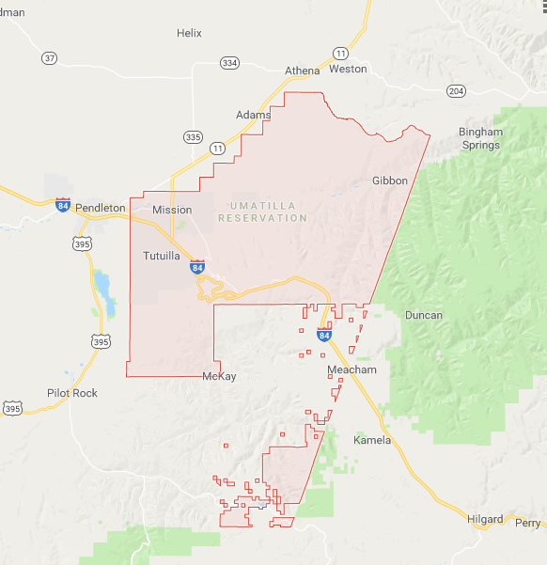

Source: Google Maps

Tribal programs, services, enterprises, and capital improvements really grew beginning in the 1980s. Building projects included new housing units, modular office and meeting spaces, the Wildhorse Resort and Casino, and the Tamástslikt Cultural Institute and Museum. A tribal Department of Natural Resources was established to work on restoring salmon to the Umatilla River. CTUIR members also have undertaken a number of renewable energy projects to enable the CTUIR to take control of energy production for the reservation and to reduce the carbon footprint of tribal businesses. A 97 kW-DC nameplate capacity solar photovoltaic (PV) array being installed on the Field Station Science and Engineering Laboratory will provide 149,203 kWh of electricity annually, saving over $12,000 in energy costs and reducing carbon dioxide emissions by 22.8 tons per year. The CTUIR also has invested in the Rattlesnake Road Wind Farm (a 103 MW facility located along the Columbia River Gorge), and installed a 123 kW solar PV array and 50 MW wind turbine adjacent the Tamástslikt Cultural Institute. The rest of the electricity used on the reservation is supplied by Pacific Power or the Umatilla Electric Co-operative (UEC), a member owned company incorporated in 1937 to serve rural areas of Northeastern Oregon. UEC purchases most of its electricity from the Bonneville Power Administration (BPA), which relies primarily on hydropower, but also on coal-fired generation, fossil fuel-fired turbines, nuclear generation, and other sources.

About 64% of residents on the CTUIR live in homes they own themselves; 36% rent their dwellings.[4] Twenty-eight percent of the residences are classified as mobile homes or trailers. Efforts to build new housing on the reservation faced a set-back when the White House’s Office of Management and Budget withdrew its funding in October of 2017. As a result, some tribal members will continue to live in dilapidated “temporary” housing.

It is against that backdrop that this case study takes place.

**Liza’s Dilemma**

After graduating with a degree in Environmental Studies, Liza returned to her trailer on the Umatilla reservation to decide how she could put that degree to its best use. She grabbed a cold beer from the cooler, sat down on the wooden front steps, and looked out at the rolling red-brown hills in the distance. She liked being away from the hubbub of cities and even from the industrial/commercial center of the reservation. The beer, the warm sun on her face, and the “white noise” from the electrical generator behind the trailer made her sleepy and she dozed.

Liza awoke with a start. Electric Generator! What if instead of running an electric generator to power her refrigerator, stove, water heater, TV, and lights, she could tap the heat of the sun? What if she installed solar panels on the trailer?

Suddenly Liza wasn’t tired any more. She had an idea and a purpose. She ran inside, pulled out her notebooks and started doing the calculations.

First, how much electricity would she need the solar system to generate? Liza made two columns on her paper. In the first she listed the appliances and gadgets she wanted to be able to power. She then estimated the amount of electricity consumed per unit time for each. Her paper looked something like this:



“Oh help!” Liza muttered to herself, chewing on the eraser of her pencil. She knew that the average American home uses more electricity--almost 900 kWh per month (10,800 kWh per year)--but it still felt like she was consuming a lot to support just one person. She pressed on.

Using a solar radiation maps she had in her school notes, she determined that her area of eastern Oregon would receive an average of about 4.5 hours of full sun per day, or about 4.5 kWh per m2 per day over the course of the year. (See Appendix A for Pacific Northwest Radiation Maps.) She calculated that a 5.5 or 6 kW solar system would more than meet her needs. A 5.5 to 6 kW system produces an estimated 400 – 1,000 kWh of electricity per month. At that rate, she might even have enough electricity to help offset the electrical demand of her auntie, who lived in her own trailer next door.

Doing a bit on on-line research, Liza determined that a 6 kW system was one of the most popular sizes available for household use. Even so, the cost would be between $15,000 and $20,000 (exclusive of any available credits or subsidies)! She would need approximately 396 square feet of roof space to house that system. Alas, she also read that because she lived in a trailer, her roof would not be capable of supporting the weight of that solar system.

Not to be deterred, Liza kept researching solar systems. She found she could install a ground mounted solar system for just about the same cost as a roof-top system. Ground mounting also meant she could angle the panels of the system for the optimal solar radiation collection—she would not be constrained by the slope of her existing roof or the direction it faced. The ground mounted system also would be easier to maintain—she could more easily sweep off the blowing dust during the summer and snow in the winter.

But how could she pay for it? She knew from her finance class that the cash flow associated with a solar system would be negative or zero for the first five or so years (she would be paying for the equipment and not yet seeing the benefit of her investment). Then she would start making money on the investment:

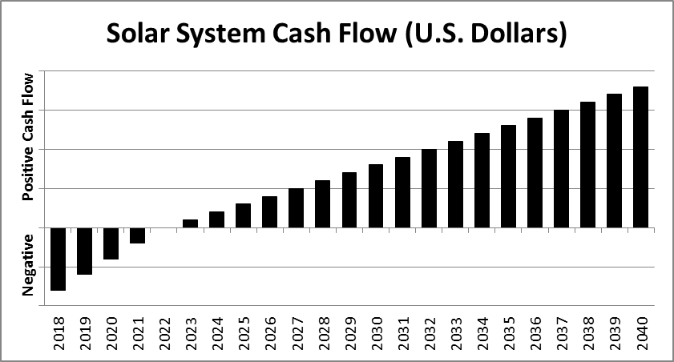

She knew she would be saving the money that she now spent for fuel for her generator, as well as for the gas she used making trips to the store to replenish that fuel. By cutting back in both of those areas, she would not be burning fossil fuels or contributing to the global warming that results from burning those fuels. It meant a lot to her to do more to protect the Earth. She thought of the words on the website for the Confederated Tribes of the Umatilla Indian Reservation: “Water was created first, life and land were created next, land promised to take care of all life, all life promised to take care of the land.”[5] Installing solar panels would help her fulfill that promise to take care of the land.

Liza looked around at the familiar rolling hills, the clear blue sky, and then at the trailer behind her. She could use the funds she had planned to set aside to replace that trailer, now that school was done, she thought to herself. It could probably last another few years with just a few minor repairs.

A Tribal Energy Program Grant might be used to offset the purchase the equipment if she were to apply through her tribal government to the U.S. DOE Field Office. However, the tribe would then own the equipment. It would not be hers. And a project as small as the one she envisioned might not qualify for some grants since it would not increase economic opportunity for the tribe or create jobs—to key funding criteria. The CTUIR might also qualify for Internal Revenue Service Renewable Energy Bonds—funds that could be used to develop a solar facility. Another option for the CTUIR might be a Department of the Interior (DOI) Office of Indian Energy and Economic Development Loan Guaranty, Insurance, and Interest Subsidy Program. That program aims to support viable Indian businesses by providing a guarantee to pay back the loan should the business default on its obligations. The government guarantee makes it easier for the businesses to secure those loans.

Liza thought she might qualify for Pacific Power’s $0.311 per kWh payment for any excess renewably generated electricity – if she could connect to the grid. But she lived far from any transmission or distribution lines. Installing lines could cost up to $60,000 per mile! That likely would not be an option either. Other rebate programs in Oregon required that she be a utility customer.

As a homeowner, Liza might qualify for a federal solar energy tax credit. The tax credit would allow her to deduct from her Federal Income Taxes an amount equal to 30% of the cost of their solar panel system minus any cash rebates she might receive. She could claim that deduction as soon as the construction of the system was completed, as long as it would be operational by December 31, 2023. That might work . . . but who knows what kind of paperwork that would entail! Liza sighed. She put away her paper with all of her calculations, but did not stop thinking about the possibility of generating electricity using the power of the sun.

As soon as word got out about her project, Liza was besieged by requests from her neighbors, near and far, about getting electricity from her solar system. She felt overwhelmed.

Beverly argued that if Liza was going to install a solar system anyway, why shouldn’t her neighbors benefit too? In the old days, Indians used to help each other. It was a matter of survival for Columbia River people. They relied on each other for food, goods not available in their immediate area, safety, and defense. This would be no different.

Cliff insisted that charging his cell phone and computer every now and then would just ensure Liza would be getting full use out of her system. He needed those devices to keep his business running. Without them, he was cut off from his customers and the outside world. Surely a cell phone and computer would not pull too much electricity from her system.

Margot claimed that since Liza would be installing the solar system on tribal land, she too had a right to the electricity generated. Liza should share the benefits of her investment. After all, 14% of households on tribal lands lack access to electricity—far above the national average of 1.4%. Margot was among that 14%. Additionally, the basic resource Liza would be using, the sun, came from nature, free of charge. Why shouldn’t others be allowed to improve their own lives by partaking in what the sun could provide?

Liza pondered some of her options.

1. Drop the project entirely. It would be too expensive and too complicated for one person to undertake.

2. Install the 6 kW ground-mounted solar PV system as planned, connecting her trailer and that of her auntie, but refusing all other requests for electricity. Access to electricity is a privilege (available to those willing to pay for it), not a right (as Margot claimed).

3. Install the 6 kW system and let others connect for short periods, free of charge.

4. Install the 6 kW system and let others share in the electricity benefits, but charge them per kWh they consume (as a utility would do). People should help shoulder the cost of the initial installation and the privilege of having electricity.

5. Work with the tribe to install a larger system on the reservation to which more citizens could connect.

If you were Liza, which path would you choose?

**Resources used in writing this case:**

Ancheta, Darkfeather. (n.d.). Native Americans and Renewable Energy. Retrieved from https://www.1tribal.com/native-americans-and-renewable-energy/

Bonneville Power Administration. (2017) BPA Facts. Retrieved from https://www.bpa.gov/news/pubs/GeneralPublications/gi-BPA-Facts.pdf

Calica, Direlle. (2014). *Northwest Tribal Energy Reference Guide: A Resource Book on Northwest Tribal Energy.* Portland, OR: Affiliated Tribes of Northwest Indians.

*Census of Housing (1990): Oregon General Housing Characteristics*. (1993) Darby, PA: DIANE Publishing.

Confederated Tribes of the Umatilla Indian Reservation (CTUIR). (n.d.). The Historical Setting. Retrieved from http://ctuir.org/history-culture/history-ctuir

EnergySage. (September 2016). Ground Mount Solar Panels: Top 3 Things You Need to Know. Retrieved fromhttps://news.energysage.com/ground-mounted-solar-panels-top-3-things-you-need-to-know/

EnergySage. (n.d.). How Much Do Solar Panels Cost in the U.S. in 2018? Retrieved from https://news.energysage.com/how-much-does-the-average-solar-panel-installation-cost-in-the-u-s/

EnergySage. (6 March 2018). Solar Tax Credit – Everything You Need to Know about the Federal ITC for 2018. Retrieved from https://news.energysage.com/congress-extends-the-solar-tax-credit/

Everything You Need to Know About a 6kW Solar System for Your Home. (2018). Retrieved from https://www.solar-estimate.org/solar-panels-101/6kw-solar-system

Greener Power for Native Americans. (12 April 2018). Retrieved from http://www.airpi.org/greener-power-for-native-americans/

Hanley, Steve. (5 November 2016). Solar Power for Mobile and Manufactured Homes. Retrieved from https://solarlove.org/solar-power-mobile-manufactured-homes/

Meisen, Peter, and Trevor Erberich. (n.d.) Renewable Energy on Tribal Lands. San Diego, CA: Global Energy Network Institute.

Mills, Patrick, and Rodney Skeen. (November 2017). Confederated Tribes of the Umatilla Indian Reservation: Solar PV Array and LED Lighting Retrofit. PowerPoint Presentation.

Misbrener, Kelsey. (7 August 2017). 8 Native American Tribes Going Solar. *Solar Power World* Retrieved from https://www.solarpowerworldonline.com/2017/08/native-american-tribes-solar/

National Public Radio. (21 April 2015). Solar Power Makes Electricity More Accessible On Navajo Reservation. Retrieved from https://www.npr.org/templates/transcript/transcript.php?storyId=401000427

National Renewable Energy Laboratory. (19 October 2004). Confederated Tribes of the Confederated Tribes of the Umatilla Indian Reservation Umatilla Indian Reservation Energy Feasibility Project Update Energy Feasibility Project Update. Retrieved from https://www.energy.gov/sites/prod/files/2016/02/f29/18_umatilla_bailor.pdf

NC Clean Energy Technology Center. (3 March 2017). Tribal Energy Program Grant. Retrieved from http://programs.dsireusa.org/system/program/detail/918

Orrick. (n.d.). Financing Renewable Energy Development on Native American Lands. Retrieved from file:///C:/Users/Greg/Downloads/1720%20pdf.pdf

Rocky Mountain Institute. (24 June 2014). Native Energy: Rural Electrification on Tribal Lands. Retrieved from https://rmi.org/blog_2014_06_24_native_energy_rural_electrification_on_tribal_lands/

At Solar Power Rocks, Our Dream is to Turn Your Thoughts of Solar Power for Your Home into Reality. Retrieved from https://solarpowerrocks.com/oregon/#incentives

University of Oregon Solar Radiation Monitoring Lab. (2004). Northwest Solar Resource Maps. Retrieved from http://solardat.uoregon.edu/Assets/ayrdn.jpg

U.S. Department of Energy (DOE) Office of Indian Energy. (n.d.). Current Funding Opportunities. Retrieved from https://www.energy.gov/indianenergy/funding/current-funding-opportunities

U.S. Department of the Interior (DOI). (13 August 2018). Land Buy-back Program for Tribal Nations. Retrieved from https://www.doi.gov/buybackprogram/FAQ

U.S. Energy Information Administration. (n.d.). How Much Electricity Does an American Home Use? Retrieved from https://www.eia.gov/tools/faqs/faq.php?id=97&t=3

Walshe, Sadhbh. (3 July 2013). Native American Tribes are Blazing a Trail for Solar Power. The Guardian Sustainable Business Blog. Retrieved from https://www.theguardian.com/sustainable-business/blog/native-american-tribes-solar-power

Wang, Deborah. (31 October 2017). White House Blocks Money for Tribal Housing On Columbia River. Retrieved from http://www.kuow.org/post/white-house-blocks-money-tribal-housing-columbia-river

White Hawk, Racheal M. (14 March 2017). Community-Scale Solar: Watt’s in it for Indian Country? Retrieved from https://environs.law.ucdavis.edu/volumes/40/1/articles/Hawk.pdf

**Other resources of interest:**

Alstone, Peter, Gershenson, Dimitry, and Daniel M. Kammen, Daniel M. (April 2015). Decentralized Energy Systems for Clean Electricity Access. *Nature Climate Change*, Volume 5, www.nature.com/natureclimatechange

Magnani, Natalia, and Vaona, Andrea. (15 May 2016). Access to Electricity and Socio-economic Characteristics: Panel Data Evidence from 31 Countries. *Energy,* Volume 103, pages 447-455.

Sustainable Energy for All (SEforAll). Retrieved from https://www.seforall.org/

United Nations Development Programme. (n.d.). Goal 7: Affordable and Clean Energy Retrieved from http://www.undp.org/content/undp/en/home/sustainable-development-goals/goal-7-affordable-and-clean-energy.html

U.S. Energy Information Administration (EIA). (25 January 2018) Electricity. State Electricity Profiles. Retrieved from https://www.eia.gov/electricity/state/

Winther, Tanja, Matinga, Margaret N., Ulsrud, Kirsten, and Standal, Karina. (2017). Women’s Empowerment through Electricity Access: Scoping Study and Proposal for a Framework of Analysis. *Journal of Development Effectiveness,* Volume 9, Number 3, pages 389–417. https://doi.org/10.1080/19439342.2017.1343368

**Appendix A: Solar Radiation Maps**

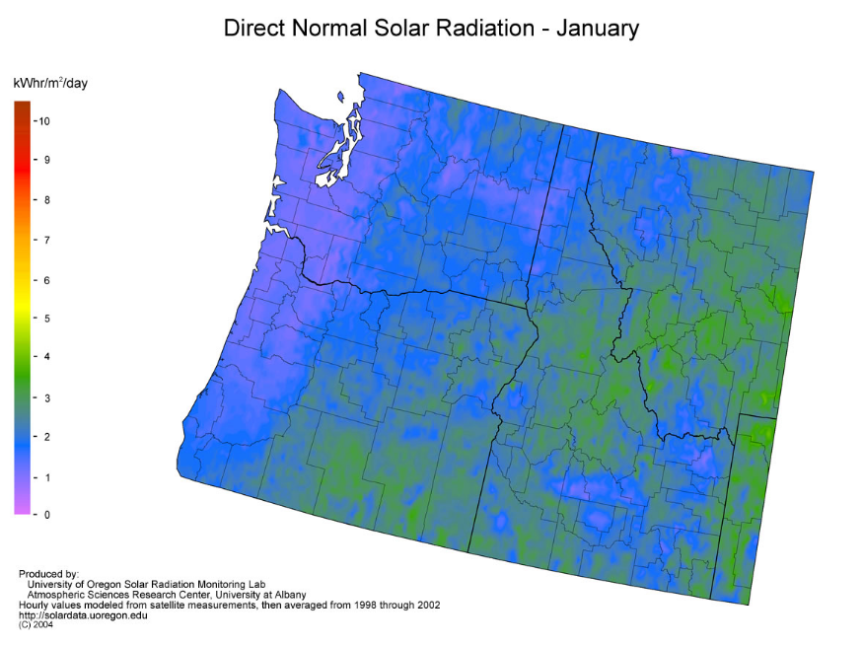

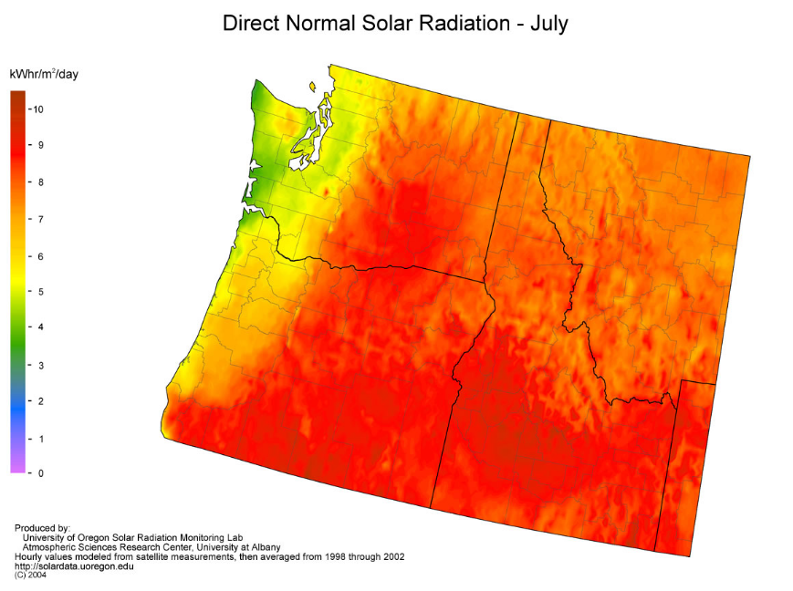

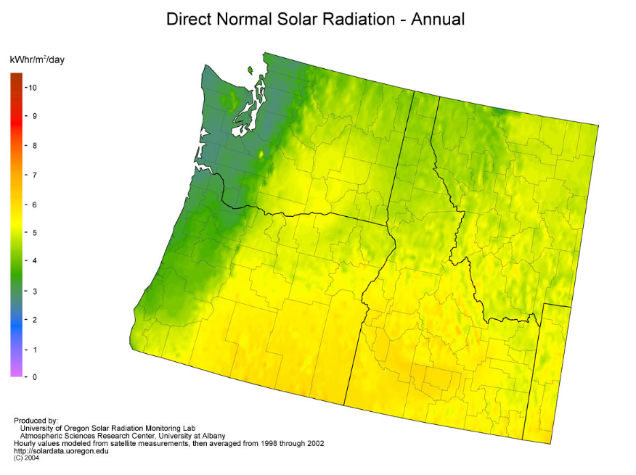

1. Copyright 2018 by The Evergreen State College. Teaching notes are available at http://nativecases.evergreen.edu
2. Thank you to Dr. Linda Moon Stumpff for her invaluable insights and suggestions on earlier drafts of this case.
3. On March 1, 2018 the Confederated Tribes of the Umatilla Indian Reservation signed an agreement with the Department of the Interior to participate in a land buy-back program. The program assists tribes in approaching non-Indian landowners for the purchase of former reservation lands lost due to allotments and other historical policies. Landowners will receive fair market value for the land; the land will then be held in trust, then ownership will be transferred to the tribe(s) with jurisdiction over the land.
4. *Census of Housing (1990): Oregon General Housing Characteristics*. (1993) Darby, PA: DIANE Publishing. p. 240.
5. Confederated Tribes of the Umatilla Indian Reservation. “History of CTUIR.” Accessed August 11, 2018 from http://ctuir.org/history-culture/history-ctuir.